 

# Placement Empowerment Program

***Cloud Computing and DevOps Centre***

***Write a Shell Script to Manage Cloud Resources:*** *Create a script to launch, stop, and terminate cloud VMs using the CLI.*

Name: Harivasan S

Department: ADS



# Introduction:

This Proof of Concept (POC) aims to develop a shell script that automates cloud VM management through the Command-Line Interface (CLI). By using this script, users can efficiently launch, stop, and terminate VMs, simplifying operations and minimizing manual intervention. This automation enhances efficiency, ensures consistency, and improves the reliability of cloud infrastructure management.

# Overview:

# This shell script automates cloud VM management, allowing seamless interaction with cloud providers via the CLI.

# It streamlines routine operations by enabling users to launch, stop, and terminate VMs with minimal manual effort.

# By reducing repetitive tasks, the script minimizes human error, saves time, and ensures reliable cloud resource management.

# Designed for flexibility, it supports multiple cloud platforms and integrates into broader automation workflows for managing complex infrastructures.

# Objective:

The key objectives of this task are:

1. **Automation:** Develop a shell script to manage cloud VMs via the provider’s CLI.

2. **Efficiency:** Streamline VM operations by automating launch, stop, and termination tasks, reducing manual effort and errors.

3. **Scalability:** Adaptable for various cloud platforms and integration into broader automation workflows.

# Step-by-Step Overview:

## **1. Set Up AWS CLI**

• **Install AWS CLI**: Follow the installation guide for your operating system.

• **Configure AWS CLI**: Run the following command and enter your AWS credentials:

* First create an EC2 Instance in your console
* You will need your AWS Access Key ID, Secret Access Key, region, and output format

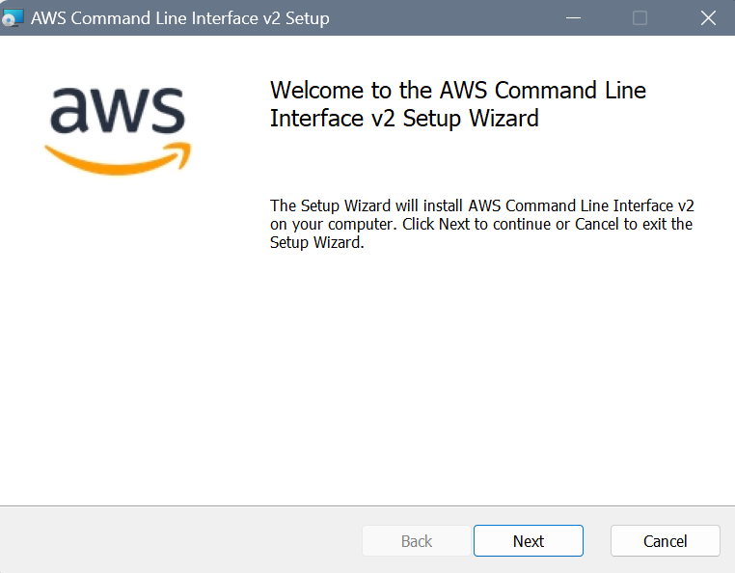

## **2. Set up your AWS CLI with your credentials**

## You'll be prompted to enter your:

* AWS Access Key ID
* AWS Secret Access Key
* Default region name
* Default output format (e.g., json)

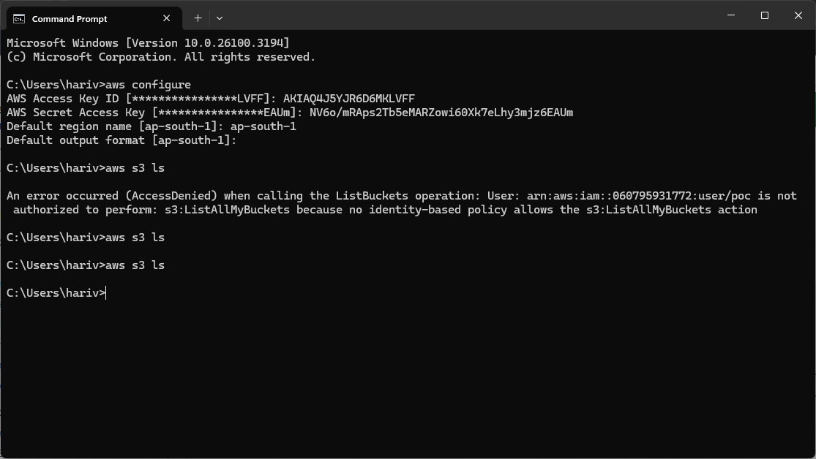

## **3. Run Instance:**

## Now run the instance in the terminal by inputting the configurations of your instance

## 

## **3. Write the script**

## Now, write the following script in a notepad and save it as ‘ec2_manager.ps1’.

## Then, save this file in a folder named script.

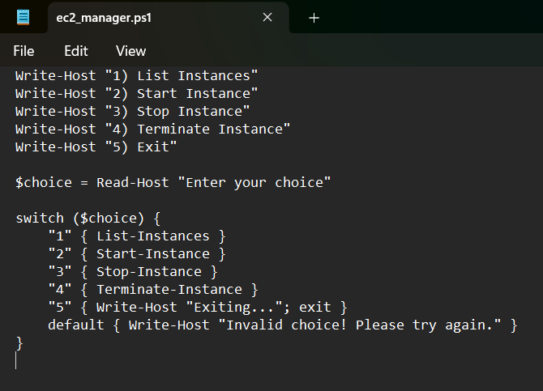

## **4. Run the script**

Now, right click on the file and click on run with powershell.

Now, the script is executed in a powershell window.

Select the required option and give the instance id of the ec2 instance you previously created.

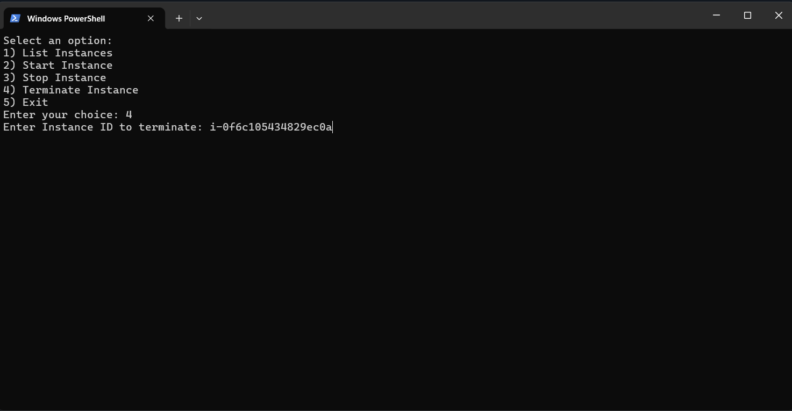

## **5. Verifying**

## Now, check the console to verify is the following actions are being performed on your given instance.

## 

### 

# Expected Outcome :

By completing this Proof of Concept (PoC) to create a Shell Script for Cloud Resource Management, you will achieve:

1. **Automation & Efficiency** – Eliminate manual VM management, automate resource allocation, and optimize performance.
2. **Monitoring & Security** – Track VM health, manage resource usage, enforce access controls, and automate updates.
3. **Cost Optimization** – Reduce expenses by stopping idle VMs and scheduling operations based on workload demands.